Data Manipulation and Reporting with Power BI:

Power BI is a powerful and efficient tool for data analysis and visualization.

It includes interactive, real time report generation in the form of graphs, charts and dashboards.

DAX in Power BI is useful in statistical data computations which help to draw insights from the data.

**Project description:**

Zomato which is a restaurant aggregation and meal delivery service based in India, provides thorough information about numerous eateries as well as consumer reviews. Zomato's owners aim to find hidden irregularities in their company's data. The ultimate goal of this project is to examine the data in such a way that they can accurately assess their business performance.

**Aim of the project:**

The aim is to construct a consolidated and interactive PowerBI report that will allow Zomato to quickly assess the required data.

**Steps:**

1. Import the data into power BI from all available excel files.

All the files are imported using Get data option in PowerBI desktop environment

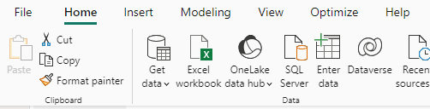

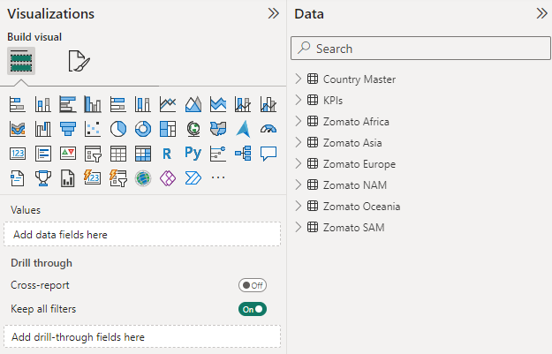

2. Data transformation: Make sure the City column names are corrected

Checked the city column in all the files to see any ambiguous characters and correct it using Transform Data – Replace values

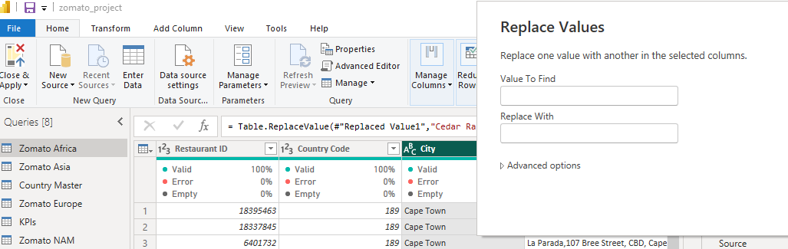

Replaced the values of the following:

1) Asia -- ÛÁstanbul with Istanbul

2) NAM -- Cedar Rapids/Iowa City with Cedar Rapids; Chatham-Kent with Chatham

3) SAM -- Sí£o Paulo with Sao Paulo; Brasí_lia with Brasilia

3. Remove any columns that aren't being used

1) Removed the column Locality verbose

4. Create two columns to display the Restaurant Name and Restaurant Address

Using delimiter ‘,’ separated the column ‘Restaurant Name, Address’ into 2 columns namely ‘Restaurant Name’ and ‘Address’

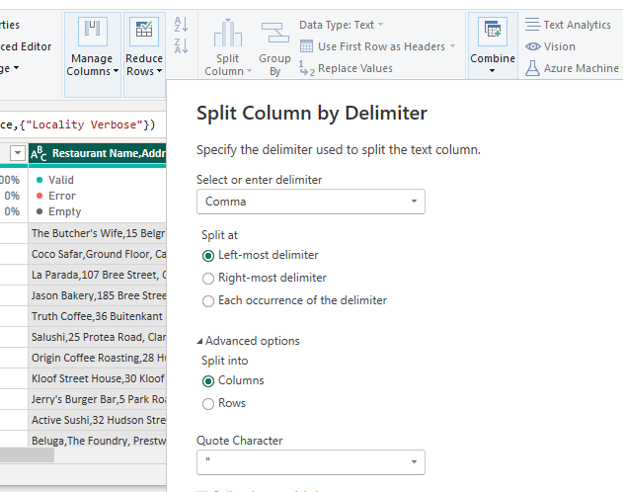

5. Make a separate table for the list of the cuisines that each restaurant serves.

Open power query editor, append queries combine the Zomato tables and keep restaurant Id and cuisine columns and remove the remaining columns.

The cuisine column is split using ‘,’ delimiter from the append table; the split columns are combined together using unpivot columns option.

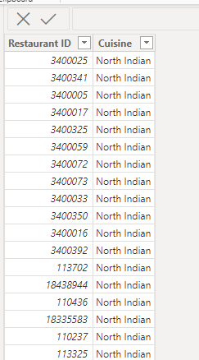

6. As it's a dimension table, the Country-Code table must only include unique and non-blank values

Removed blank rows and duplicates from the country-code table

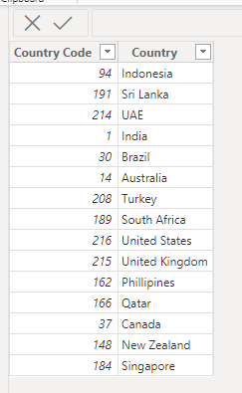

**Steps to use DAX in the project:**

1) Add a Rating color column in an appropriate table with the data rows in the format given below: Aggregate rating Rating color Above 4.5 Dark Green 4 to 4.4 Green

Added a new conditional column Rating color to the table ‘KPIs’

Rating Color = SWITCH(TRUE, KPIs[Aggregate rating] >=4.5, "Dark Green",KPIs[Aggregate rating] >4, "Green", KPIs[Aggregate rating] >=3.5, "Yellow", KPIs[Aggregate rating] >=2.5, "Orange", KPIs[Aggregate rating] <2.5, "Red")

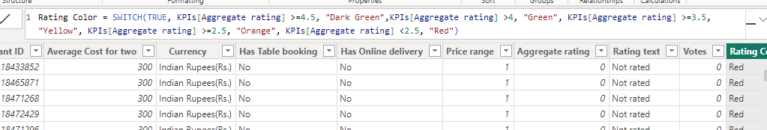

2) Create the following measures in the appropriate tables

a. Restaurant count – Created new measure in Zomato table with command

Restaurant Count = DISTINCTCOUNT('Zomato Cuisines'[Restaurant ID])

b. Average cost – created new measure in KPIs table with command

Average cost = AVERAGE(KPIs[Average Cost for two])

c. Average rating -- created new measure in KPIs table with command

Average rating = AVERAGE(KPIs[Aggregate rating])

d. Cuisine count -- created new measure in Zomato Cuisines table with command

Total Cuisines = DISTINCTCOUNT('Zomato Cuisines'[Cuisines])

3) Create a new column in the Country Code table and name it “Continent” and create the values using the below-mentioned convention Note: The mapping is continent - country, for example ''Africa – South Africa''

Applied Transform Data to Country code table and add new conditional column as ‘Continent’ with the following conditions:

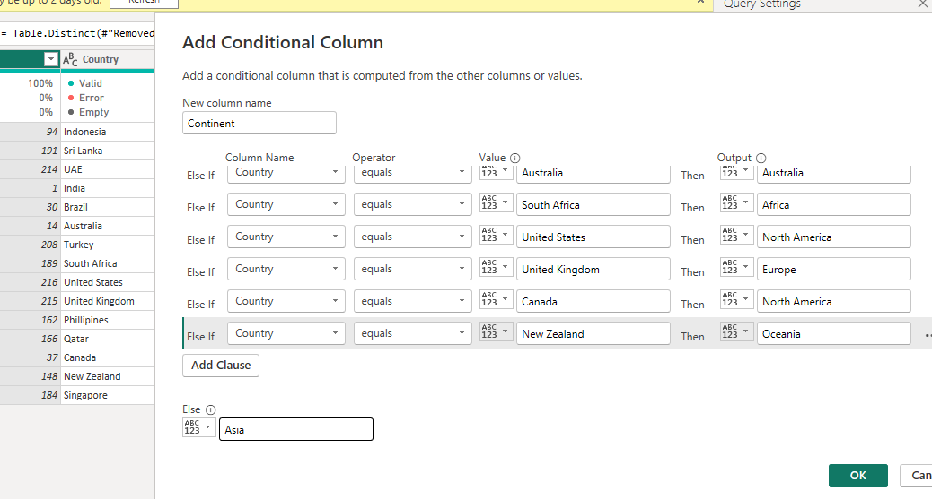

**Data Analysis and Report Generation:**

1) Derive data on the total number of restaurants worldwide, including continents, countries, and cities

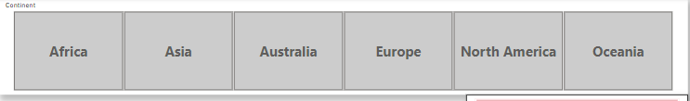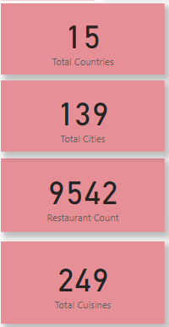

2) View data on a global scale with the capacity to drill down to a granular level

3) Derive data on the restaurants with the highest average customer ratings

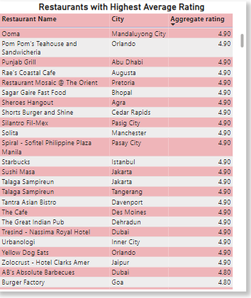

4) Discover the restaurants with the lowest average costs

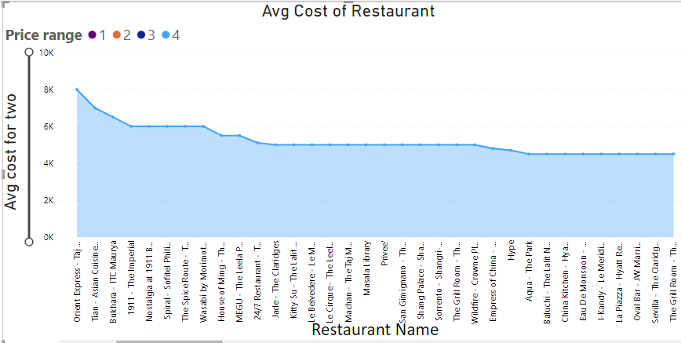

5) Filter and view information on the restaurants based on:

Their geographical dimensions such as continent, country, and city.

The service they provide, such as online ordering or reservation services

The average rating slab by the color.

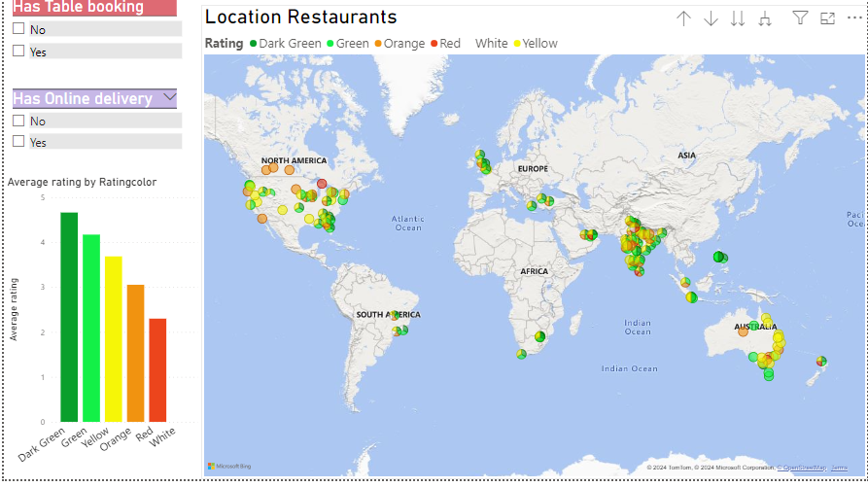

6) Identify the restaurants with the most cuisines served

